**EXP 1**- Design an LED Flasher

**Circuit diagram –**

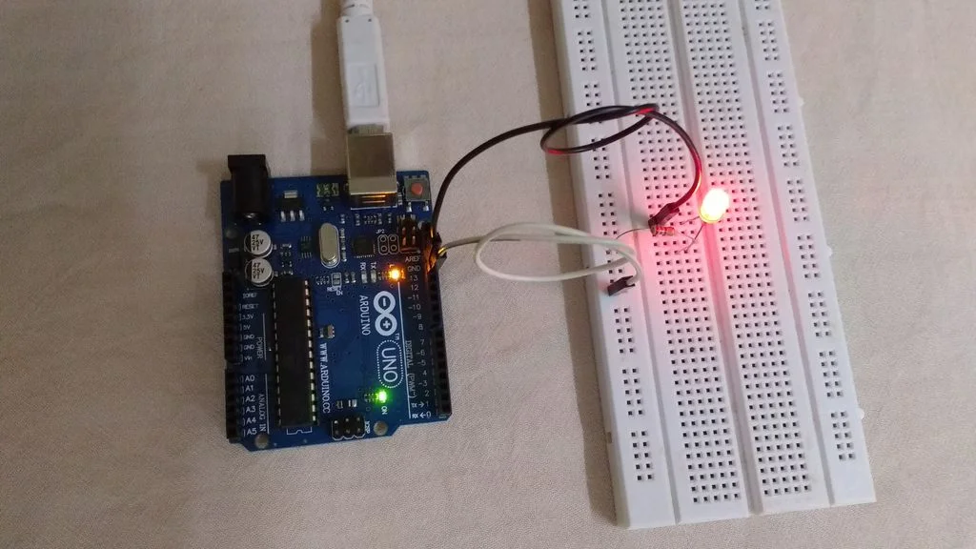

**THEORY**

Concepts used :-

Requirements(Hardware)

1 LED

1 Breadboard

1 Arduino

1 Resistor

1 Jump Cables

1 Computer

Requirements(Software)

Arduino IED Software

STEP 1:-

Take an led and determine positive and negative leg

STEP 2:-

Take a breadboard and determine flow of current in breadboard

STEP 3:-

First and last two rows – current flow row wise

Middle lines -current flow in column wise

STEP 4:-

Make a circuit as shown in the diagram

Arduino’s pin connected to positive leg of LED through resister

Arduino’s GND is connected to negative leg of led

STEP 5:-

Write code and upload it on arduino.

To upload code into arduino, need to attach arduino with pc using USB cable which is come with arduino board.

Now, In arduino IDE goto FILE>Examples>Basic>Blink or copy this code and press upload in toolbar.

Code-

// the setup function runs once when you press reset or power the board

void setup()

{

// initialize digital pin 13 as an output.

pinMode(13, OUTPUT);

}

// the loop function runs over and over again forever

void loop()

{

digitalWrite(13, HIGH); // turn the LED on

delay(1000); // wait for a second

digitalWrite(13, LOW); // turn the LED off

delay(1000); // wait for a second

}

**PRECAUTIONS:-**

1-The conections should be tight.

2-The Arduino board should be working properly.

3-Coding should be done properly.

**LEARNING OUTCOMES:-**

ARDUINO UNO is an ATMEGA controller based board designed for electronic engineers . Arduino based program development environment is an easy way to write the program when compared to other environment development programs.